The Educator’s Room
A Weekly Round-up of Events, Articles and Resources for educators in K-12 Education.
March 15, 2020

In This Issue:

- Administration Offers Guidance to Schools as They Shut Down on Their Own
- “NYC Schools to Close Monday for at least 4 weeks amid Coronavirus Pandemic
- “Please do a Bad Job of Putting Your Courses Online”
- “Does closing schools slow the spread of the coronavirus?”
- “It’s Taken a Pandemic to Save Teacher’s Mental Health”
- “Once Again Teachers are First Responders”
- Teacher Self-Care Calendar 2020
- NEA teacher union, the largest U.S. labor group endorses Biden

Quotes of the Week
“Many teachers and staff feel like guinea pigs and disposable right now during a global pandemic because our society didn’t have protections and a safety net for young people in poverty, in this failed healthcare system. We teachers know this every day as we go teach and do our jobs and serve young people, which I love doing and which has been my calling since I was six. Teachers do everything, and this is yet another case where everything we do isn’t enough, AND we are expected to carry the burden for a larger society that won’t carry the burden.” Anonymous Teacher, Once Again Teachers are first responders”

Education News Articles:

Has Your School Closed Due to the Coronavirus? (Published March 10, 2020)
- “ Opinion: Things are Weird Right Now” (Published March 8, 2020

- “What Effective Principals Do” (Published March 10, 2020)

Teacher Self-Care Articles

- Are Teachers in Trouble? (Published March 5, 2020)

What is the relationship between the emotional load of teachers’ work and individual manifestations of illness? We need to document and address clinical needs – such as pain, functional impairment, mental illness and social isolation– that go deeper than simple “wellness programs.

2.3 Signs You Need Self-Care, Stat

There’s a reason why airlines’ in-case-of-emergency instructions include a reminder to secure your own oxygen mask before assisting others. Taking care of ourselves is what allows us to care for our families, our friends, and our communities. This is why the time we need to set aside for self-care activities is neither optional nor negotiable. We cannot pour from empty cups, rescue from sunken ships, or be the light when drowning in darkness. “Without self-care, our health suffers,” says Ken D. Porter, program manager at the Mood Disorders Society of Canada.

3.Teacher Self-Care Calendar 2020

LARGE, DESIGNER DESK PAD calendar perfect for desktop decor and monthly planning around teacher self-care.
STUNNING, STATEMENT PIECE, with 12 vibrant colors, a different one for each month.

PRETTY & PRACTICAL DESK CALENDAR - great for monthly planning, office or countertop decor & tracking self-care.

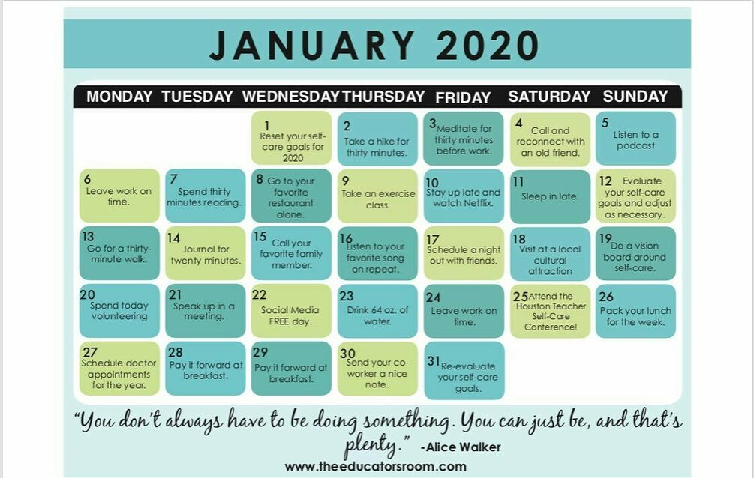

Research Articles

1. Suffering from Compassion Fatigue?Life Stress?

Denial is one of the most detrimental symptoms of Compassion Fatigue and Life Stress. It can easily hinder your ability to assess the level of fatigue and stress in your life as well as thwart your efforts to begin the healing process.

2.Why We’re Doing School All Wrong

The world has changed greatly ever since the school system first came to be. Although we’ve modernized the tools we teach with and the environment we teach in, we’ve neglected to re-design the overall structure and outcome of the typical school day. As a high school teacher, I believe we’re doing school all wrong.

3. How to Spot Dyslexia, and What to Do Next

3. How Combining Mindfulness, Compassion, and Gratitude Can Bring About Emotional Healing

Attempting to overcome past trauma can lead some to fall into anger, self-harm, and substance abuse as coping mechanisms, which end up causing more harm. Overcoming these issues can seem downright impossible. In this conversation between Tim Ferriss and Dr. Gabor Maté, the pair discuss a powerful way to reframe these mechanisms through compassionate inquiry,gratitude, and mindful introspection, that can help craft a new path towards recovery and healing.

© Copyright 2020 The Educator’s Room LLC

If you have feedback or suggestions,

please e-mail info@theeducatorsroom.com
About The Educator’s Room Newsletter

Mission and focus:
This weekly newsletter was created to keep teachers, principals, superintendents and other leaders informed about teaching and learning. The Educator’s Room mission is one that is simple, yet straightforward for so many teachers: To empower teachers to be the experts in education. Through articles, events, and social media we will advocate for honest dialogue with teachers about how to improve public education. This mission is especially important when reporting on education in our community; therefore, we commit our readers to integrity, accuracy, and independence in education reporting. As a way to reinforce these principals we vow to be transparent in our sources for revenue to include (but not limited to): contributions from readers; paid sponsorships through our website and email newsletter, major donations from foundations, our jobs board and our paid webinars. This belief of being diversified on how we monetize solidifies our independence and allows us to report new ethically.
Before highlighting any article, we take into carefully consideration the publication, date of publishing and intent of the writing. We value articles written by fellow educators, practitioners, or researchers. If you are interested in having your writing featured, please send an email to info@theeducatorsorom.com .

How to Subscribes:
Our newsletter is free. To subscribe, please click here. Please note that once you opt in for emails you may be sent other resources outside of this newsletter.

Website:
If you go to http://www.theeducatorsroom.com you will find thousands of articles from teachers around the world on all topics affecting teaching and learning.

